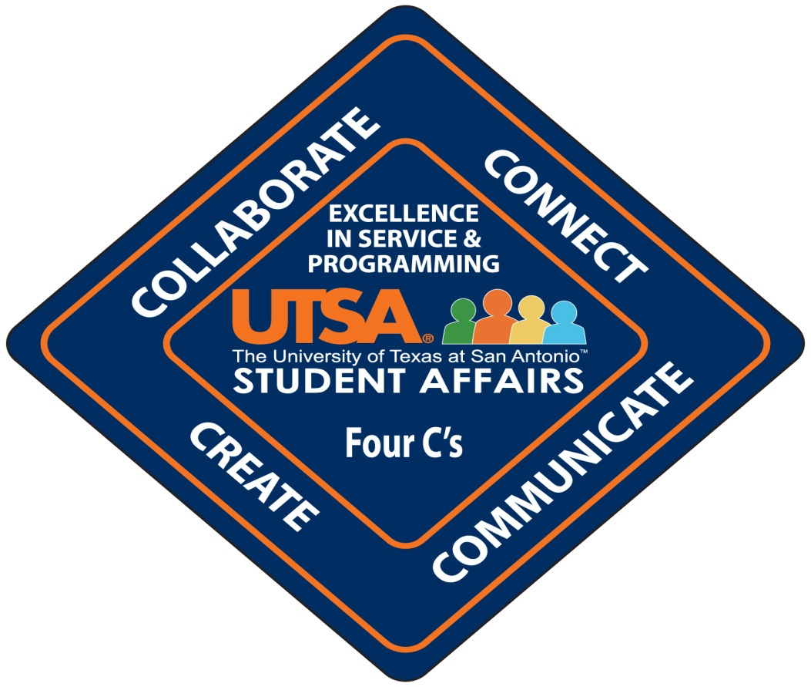

Four C’s Training ---- 2013 fall semester
(SD 415)
The Four C’s is Student Affairs conceptual model used to pursue our path of achieving Excellence in Service and Programming. All new staff are required to attend the True Colors workshop to understand the division’s common language and then attend the Four C’s workshop to learn our vision, mission, core values and how to collaborate, connect, communicate, and create to achieve excellence. Employees should coordinate their class attendance schedule with their supervisor and then email B.J. Gola @ bj.gola@utsa.edu to register for one of the following Four C’s Training classes. Attendance is mandatory. (NOTE: Completion of a True Colors Class is required before an employee can sign-up for a Four C’s Class.)
Four C’s Training (SD 415) ----2013 fall classes are scheduled as follows:
Date | Time | Room Locations | Deadline for  Sign-Up
October 29, 2013 (Tuesday) | 9:00 – 12:00 noon | Harris Room/HUC 2.212 | 10-21-13
November 4, 2013 (Monday) | 1:00 – 4:00 pm | Harris Room/HUC 2.212 | 10-25-13
November 7, 2013 (Thursday) | 9:00 - 12:00 noon | Harris Room/HUC 2.212 | 10-29-13

